Week1 Assignment
Kalpana Renjarla
CT5150 Data Science Tools – CRN196
Perkins
New England College
07-18-2026

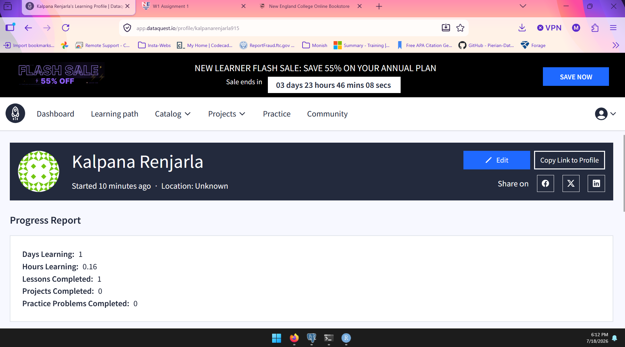
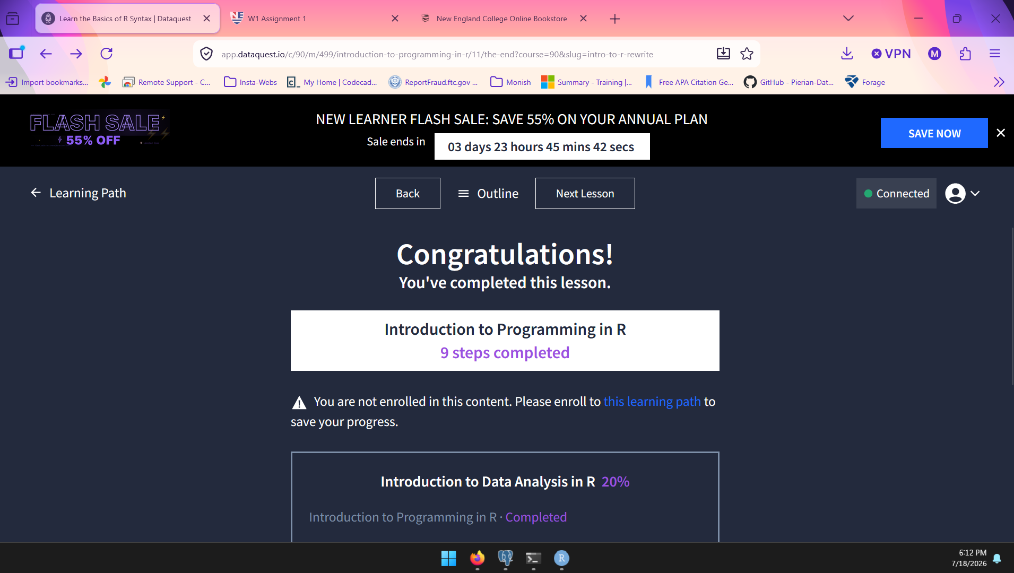
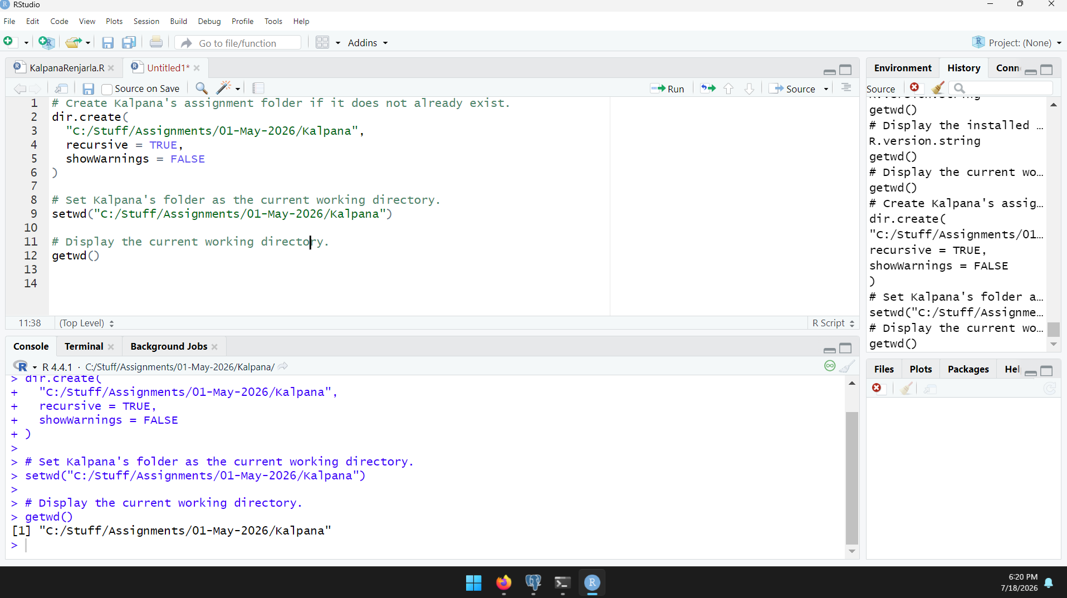

I successfully completed the four required R lessons and practiced fundamental concepts, including programming basics, arithmetic expressions, variables, logical expressions, and vectors. I also used RStudio to identify the installed R version and verify the current working directory using the getwd() function.

